

**UNIVERSITY OF PETROLEUM & ENERGY STUDIES**

**College of Engineering Studies Dehradun**

**LAB FILE**

**Experiment 8**

Programme : B. Tech in Computer Science and Engineering with Specialization in DevOps

Course : Continuous Integration & Continuous Deployment Lab

No. of credits : 1

Semester : V

Session : July-December 2020

Batch : 2018-2022

Faculty : Dr. Hitesh Kumar Sharma

Submitted By:

Ingit Singhal

Sap id: 50056426

Roll No : R171218048

**LAB EXPERMENT 8**

**Implementing Master /Slave Architecture in Jenkins**

**SCREENSHOTS**

**1. Start your Jenkins and open Nodes option > Click on New Node> Name the new node.**

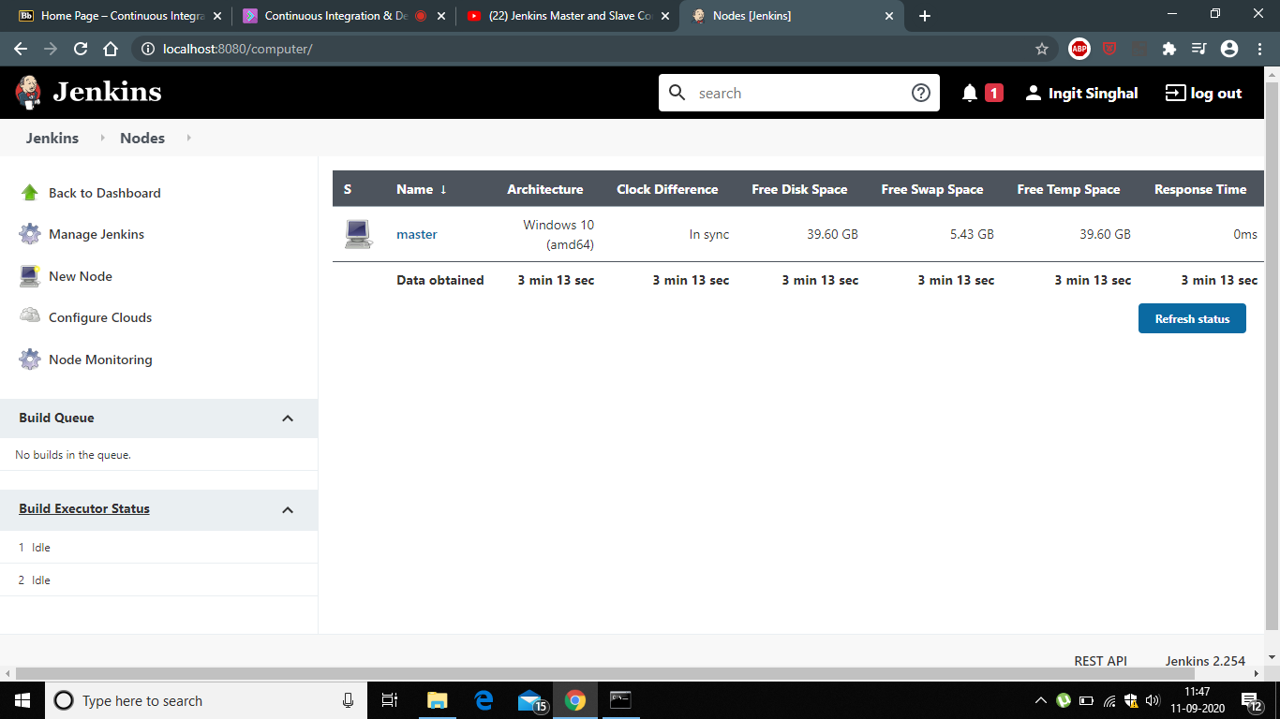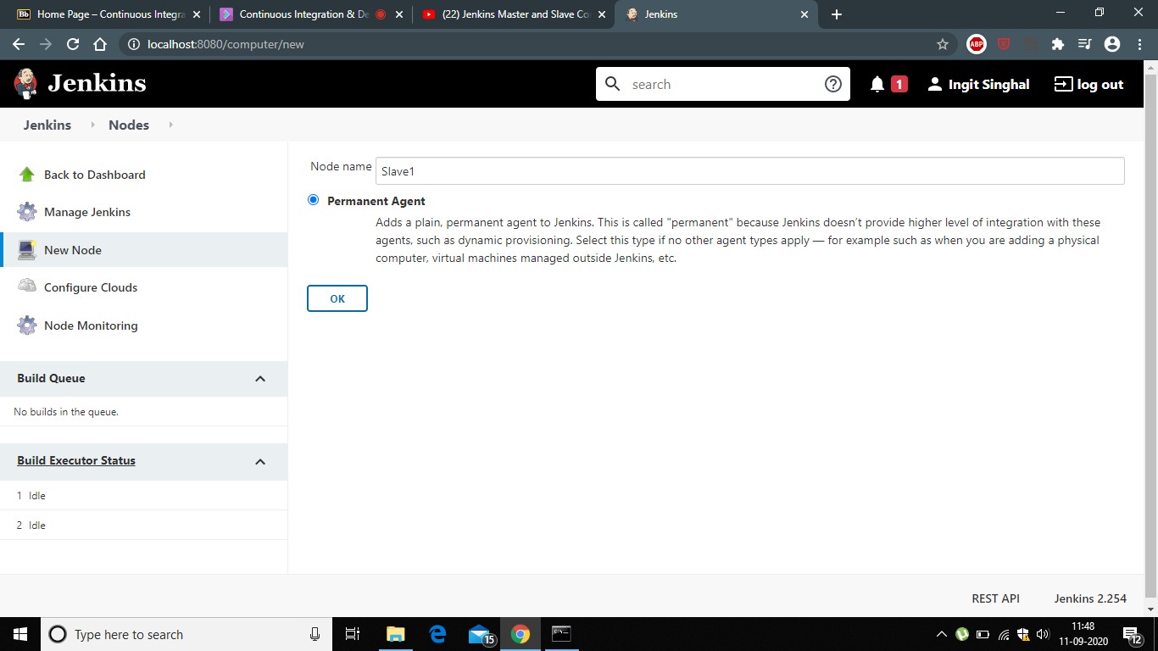

**2. Open Configure Global Security and do the mention settings**

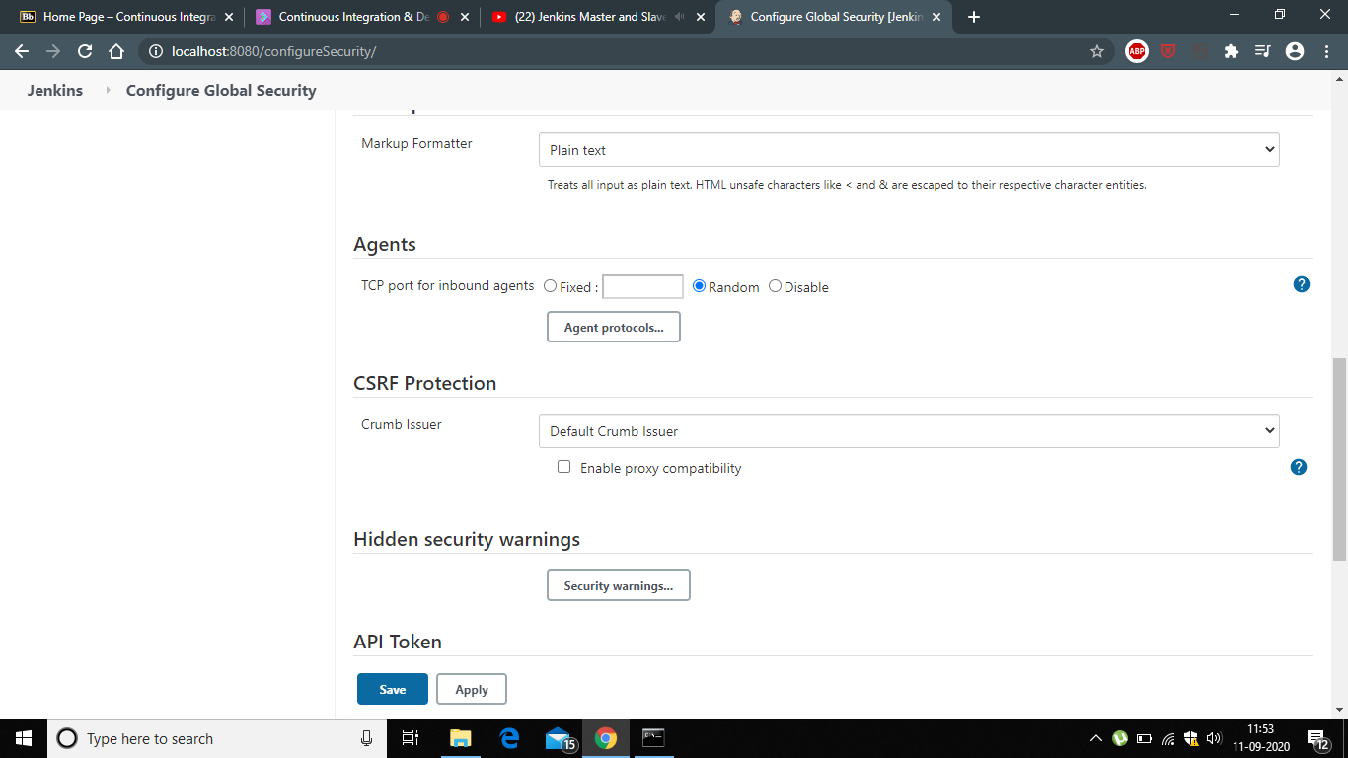

**3. Download agent.jar file by clicking on the link shown below.**

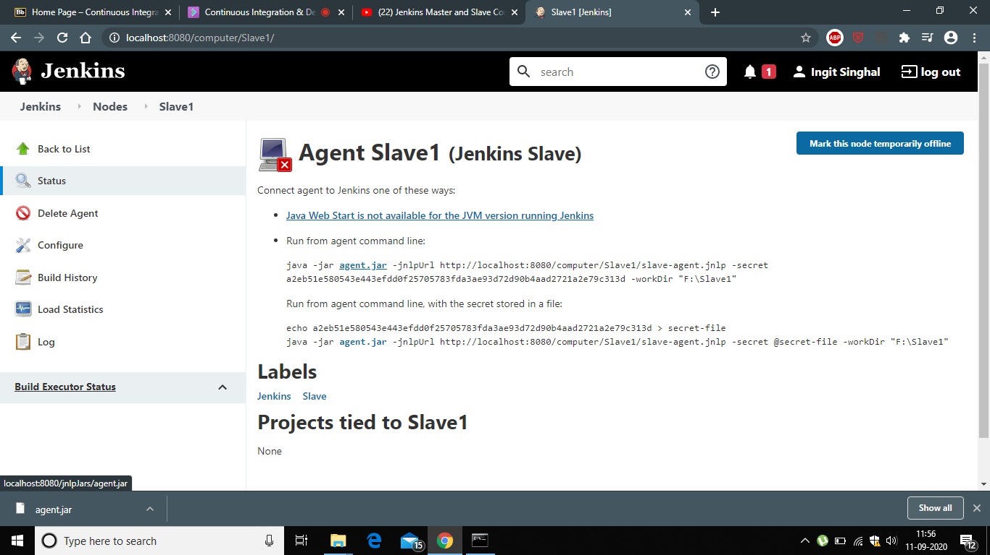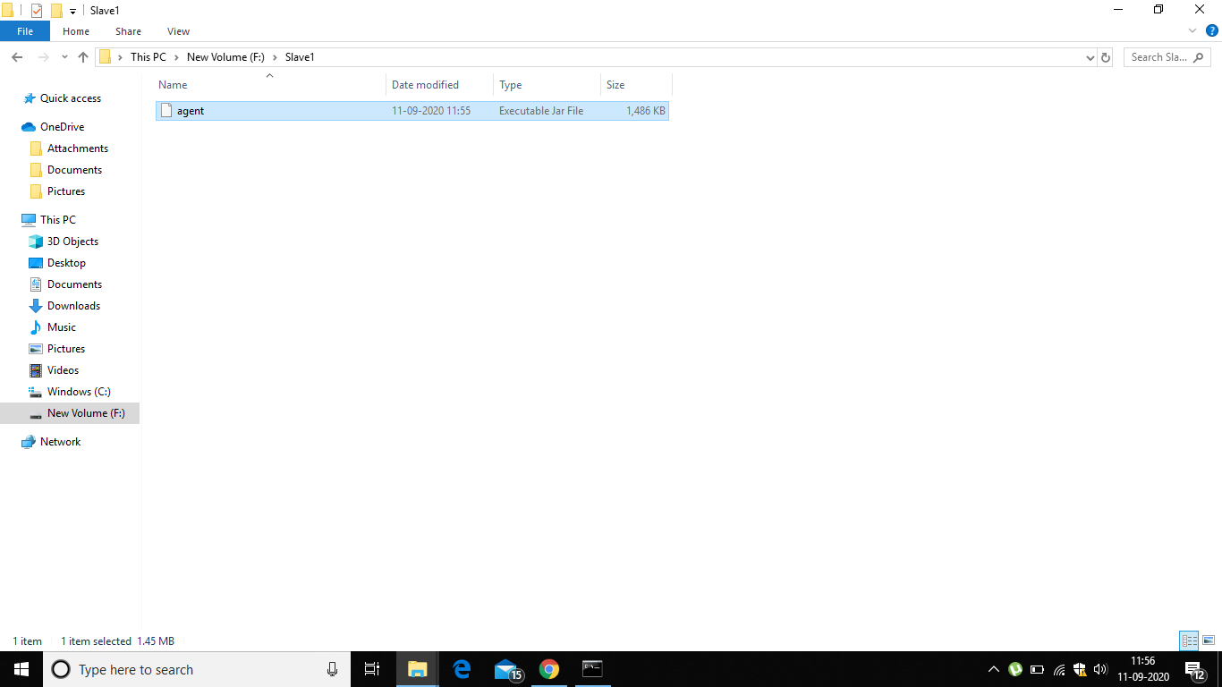

**4. Now open Command Prompt , give the path of directory where agent.jar is located and run the command “java -jar agent.jar”.**

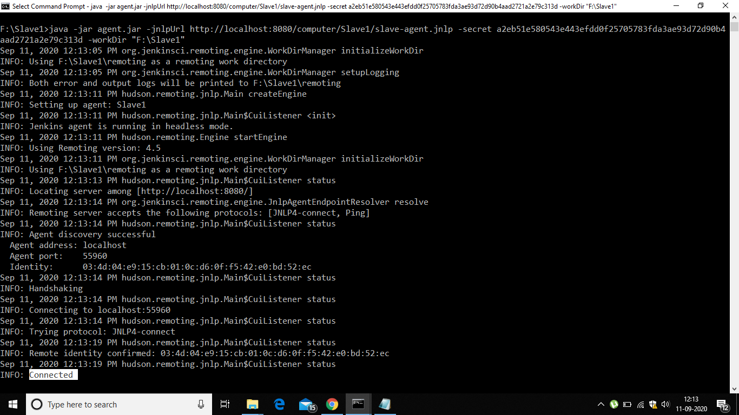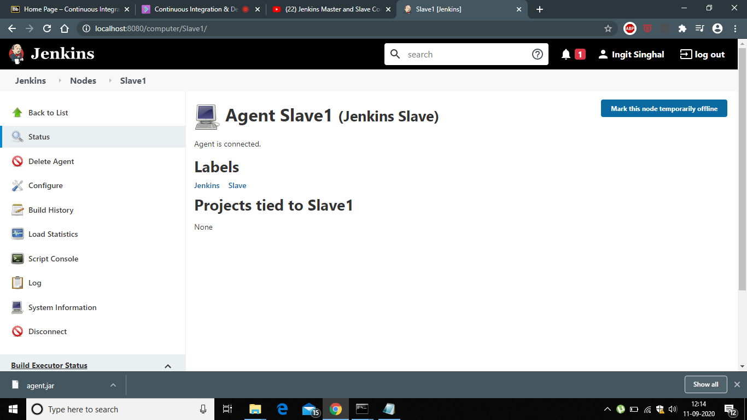

**5. Now successfully run the pipeline under slave node.**

